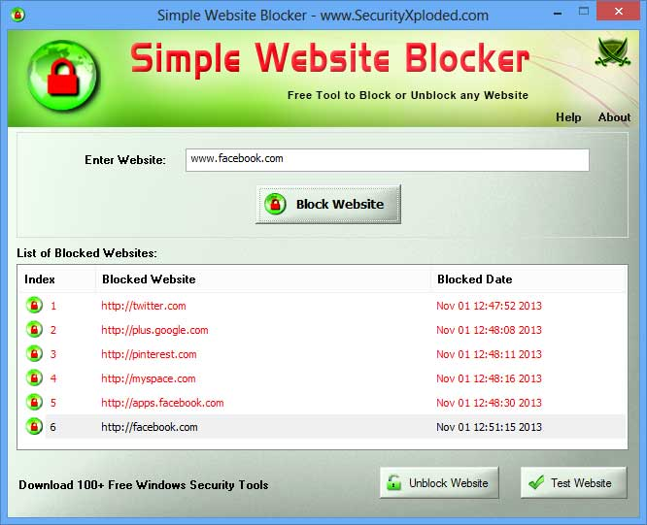

Three framers that are separate vertically

List of block website, unblock options and history of block website, also adding test website

Goals now

1. For safety purposes, we are creating a copy of the host file to be used for the development of this application
2. Testing and using tutorial codes first before developing my own

Development tasks:

1. Creating middle frame: entry , label and button I think it is better to put them in the static method
2. Creating bottom frame: history , list and unblock

Packages needed:

Webbrowser, for the purposes of testing if the website is block with the test website button

Validators, for the purpose of checking if user input, is an actual valid link – rejected

Using requests instead because validators doesn’t check if the website is legit or not

Using platform to check the user operating system

Buttons:

Left, right, block, unblock, test, history

Block button task

Working on the function command:

1. Check if url is valid or not
2. If its not valid, return a messagebox error
3. Turn the url into www and none www
4. Check if the url is in the host file or not
5. If not, add it in with the ip address + “\n”
6. After adding add messagebox saying it successfully added
7. Update the bottom frame to include the new url
8. Update the history too or dict
9. If yes, , use messagebox saying it is already blocked

Gonna tr developing the project first using the copy before using the real host file

Note: you have to run script as administrator

Radiobutton:

Indicator = 0 , background = “light blue”

Use command

Final tasks:

1. Add comments to improve readability
2. Add unblock button cmds
3. Add history_button cmds
4. Add readme.md and requirements.txt